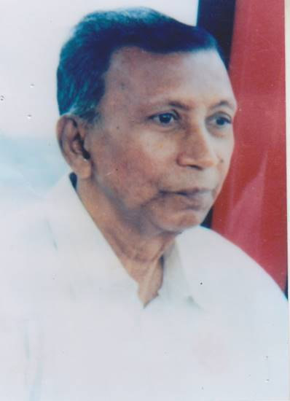
Name: Prof. S.M. Mokhlesur Rahman

NID No: Information not known

OGSB Voter no: Information not known

BMDC Registration No. Information not known

Summary about you in one sentence:

Date of Birth: 01.08.1920

Father’s Name: Momtaz Uddin Ahmed

Mother’s Name: Ismatun Nessa

Spouse Name: Jahanara Rahman

Detail address:
Native Village: | Char Mollikpur | Upazilla: | Lohagara | Zilla: | Narail

Address (present) | Thana Rd, Narail Town, Narail

Tel/Mobile | Personal: | 01713064992 | Office: |  | Email:

Educational qualification:
Degree/certificate | Institution | Month/Year  Of Passing | Remarks
Matriculation | Barisal Zilla School | 1939
ISC | BM College, Barisal | 1941
MB | Calcutta Medical College | 1947
LM | Rotterdam | Not Known
DGO | Dublin, Ireland | 1964
DORCP | Ireland | Not Known
ATFM | USA | Not Known

Last Designation/Current Position: Professor from Dhaka Medical College

Last Institution: Dhaka Medical College

Training experience in 5 sentences: Information not known

Name of dissertation/Thesis: Information not known

Major Publications: Information not known -

No. in National Journal: Information not known

No. in International Journal: Information not known

Areas of interest: Maternal Health

Achievements of life:

Extra-curricular Activity:

Hobby: Reading and travelling

Children:
Name | Achievements | Address
Mosleh Uddin (Son) | Businessman  Director of Planet Group | Flat no. 4A2, House no. 71, Rd no. 8/A, Dhanmondi, Dhaka  Mobile: 01713064992
Anawara Kaiser (Daughter) | Housewife
Monawara Hossain (Daughter) | Housewife

What is your aspiration/dream about OGSB?

Any post held in OGSB:

Name of the post | Period | Name of the branch
Information not known

Professor Dr. Mokhlesur Rahman was born in Char Mollikpur of Lohagara Upazila, Narail on the of August 1st, 1920. He passed his Matriculation in 1939 from Barisal Zila School in the 1st division and received an A.K Gold Medal with distinction and passed ISC in the 1st division from Barisal BM College in 1941, got admission in Calcutta Medical College and passed MB in 1947. Further he worked as R.M.O in Islamia Hospital, Calcutta.
He then came to East Pakistan and served as an Assistant Surgeon in EPMS (Upper) Service and worked as a resident surgeon in the department of Gynaecology and Midwifery under Professor Dr. Habibuddin Ahmed in Dhaka Medical College till 1953.
Later in January 1953, he was transferred to the Mymensingh Litton Medical School as a lecturer, Gynaecology. After 6 years he was transferred to Sylhet Medical School as lecturer, Dept. of Gynaecology. He went to London for higher education in 1962 with a government scholarship. After his return in 1964 he started teaching at Mymensingh Medical College and later transferred to Dhaka Medical College in 1978 as a professor in the Dept. of Gynaecology. He retired from Dhaka Medical College in 1980 and later he was associated with Rashmono Poly Clinic.
In 1980, he moved to Narail. In 1981, he performed the Holy Hajj. He passed away on December 31, 1995 at BIRDEM Hospital, Dhaka due to cancer and was buried at his hometown.

Important events during his lifetime:
- When he was a medical graduate, one day he and his father were having friendly conversation with other villagers in the balcony. One of the villagers informed them that a lady was died during delivery. All heard and act it as a natural death but no one raised any questions on the reasons of the death and initiatives taken to save the mother. This incident really made him upset and he decided to become a Gynaecologist. Throughout the life he worked for the maternal health services. He said that “Every organizations have their representatives but there is no representative for pregnant mother; I am the representative of the mother; I want safe motherhood like safe fatherhood.” He wanted every mother should deliver their baby in hospital. He also suggested the parents that during marriage of their beloved daughter, they should take written consent in “Kabin Nama” form the groom to assure hospital delivery for their daughter.
- He was a man of punctuality. He strictly maintained it in his professional life as well as his personal life.
- When he was being offered as a principal of Dhaka Medical College, he refused and said “A man of Principle cannot be a principal”. He also refused the government's nomination for MP at that time.
- In his late life, he stayed in his own house at Narail town. Many of his friends suggested him to stay at Dhaka. He said, “I studied on the stipend of Jessore Zilla Porishod. I want to repay the debt to the people of Narail.” His fee was only 32.5 taka per patient. He never hankers after money. He followed the medical ethics and never took fees from doctors’ family.
- He was very strict in maintaining the quality of medical education. He hated lobbing for passing exam and thought it as a punishable offense.
- He discouraged all medical professionals to be involved in any type of political activities.
- By the request of Mr. Juhurul Islam, Prof. Dr. Mokhlesur Rahman took the responsibility to establish Juhurul Islam Medical College, Bajitpur. It was the 2nd private medical college (1st hospital based medical college) in Bangladesh. After his death, the management of Juhurul Islam Medical College, named the main auditorium as “Prof. Mokhlesur Rahman Auditorium”.
- He was closely associated with Ad-Din Hospital, Jashore.
- He was deeply involved with various NGOs and various social welfare organizations for socioeconomic development and providing better treatment to the poor patients.

Thanks

